Oracle Analytics Cloud
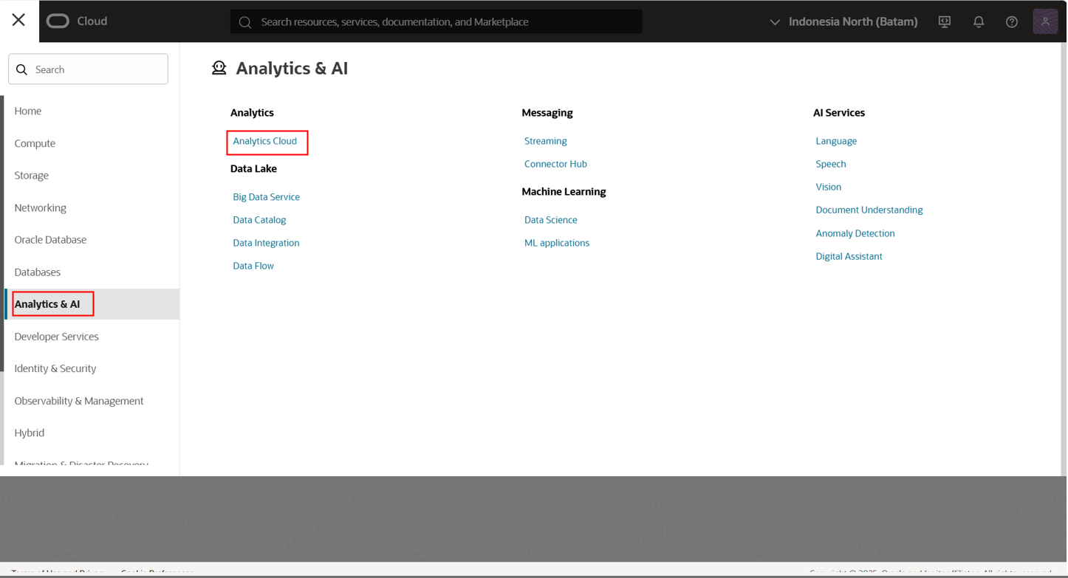
Klik analytics Home Page
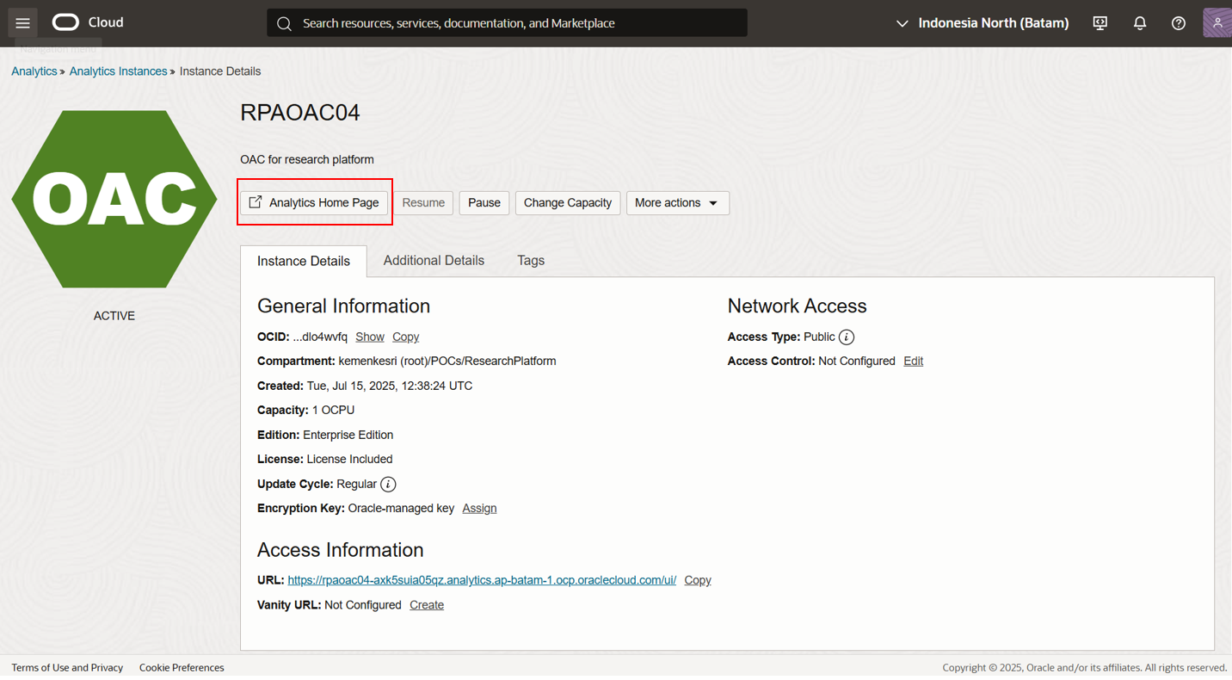

Connecting to database
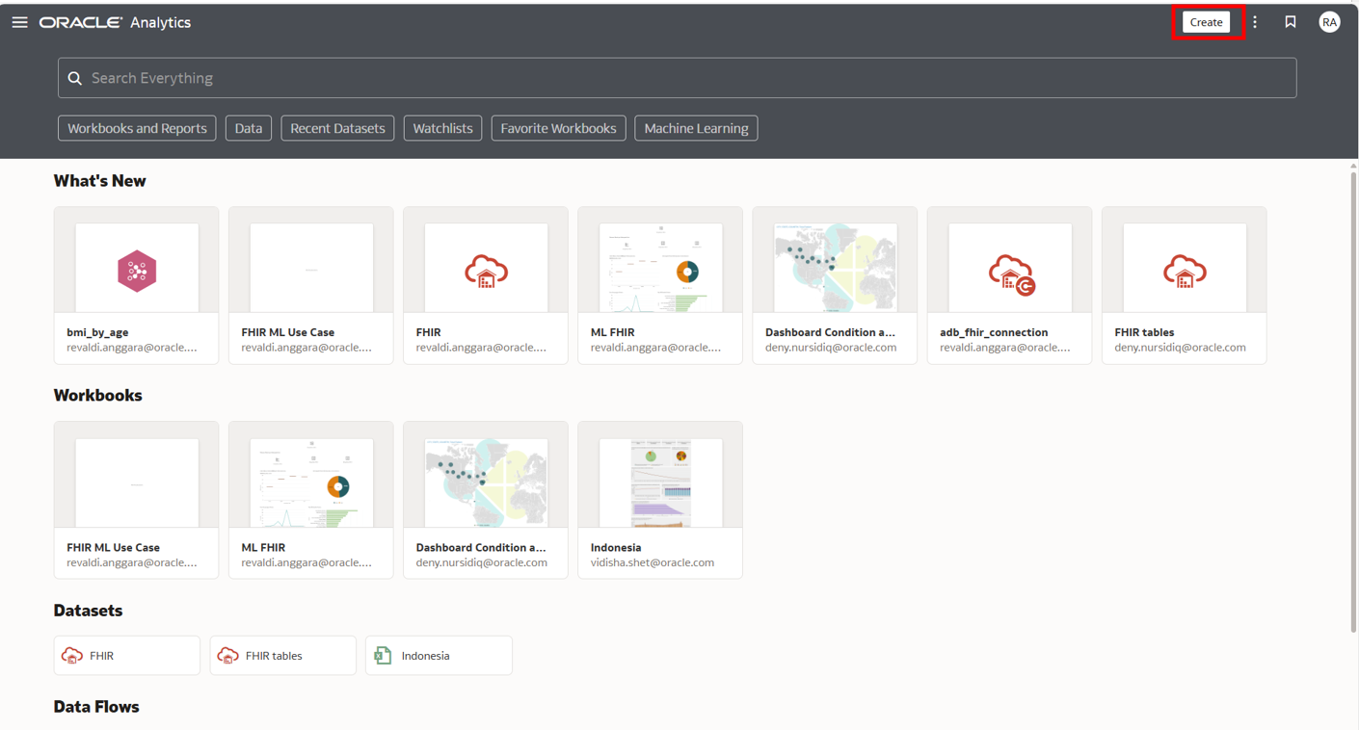
Create dataset
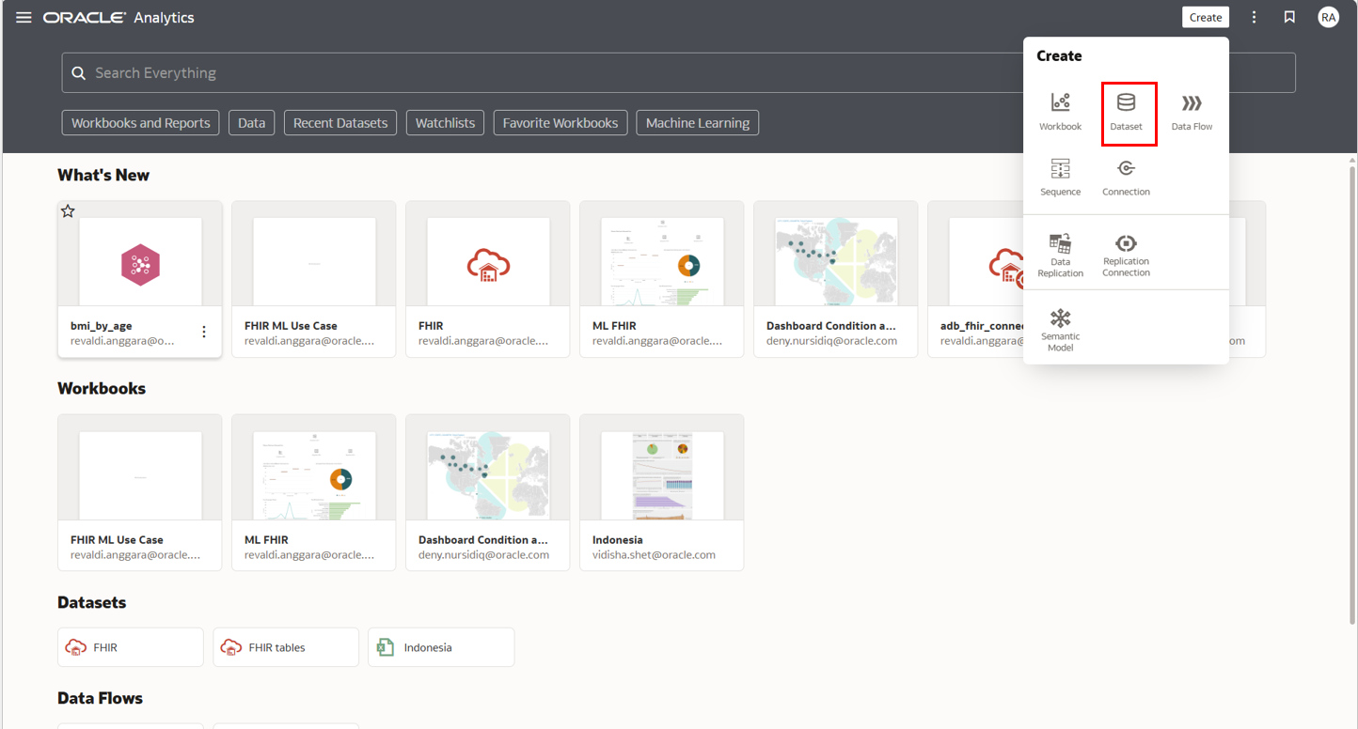

Koneksi dari compartement yang sama (ResearchPlatform to ResearchPlatform)
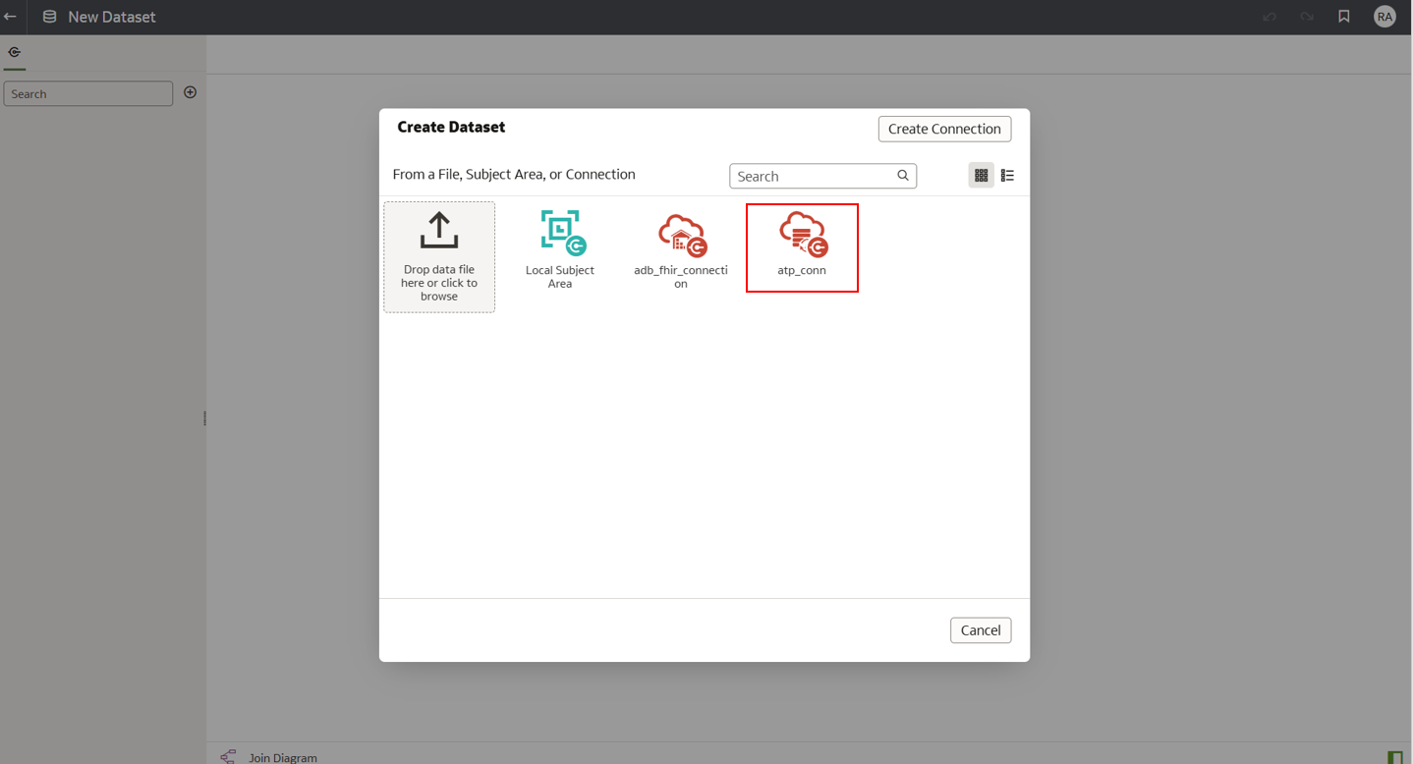
Buat data workflow
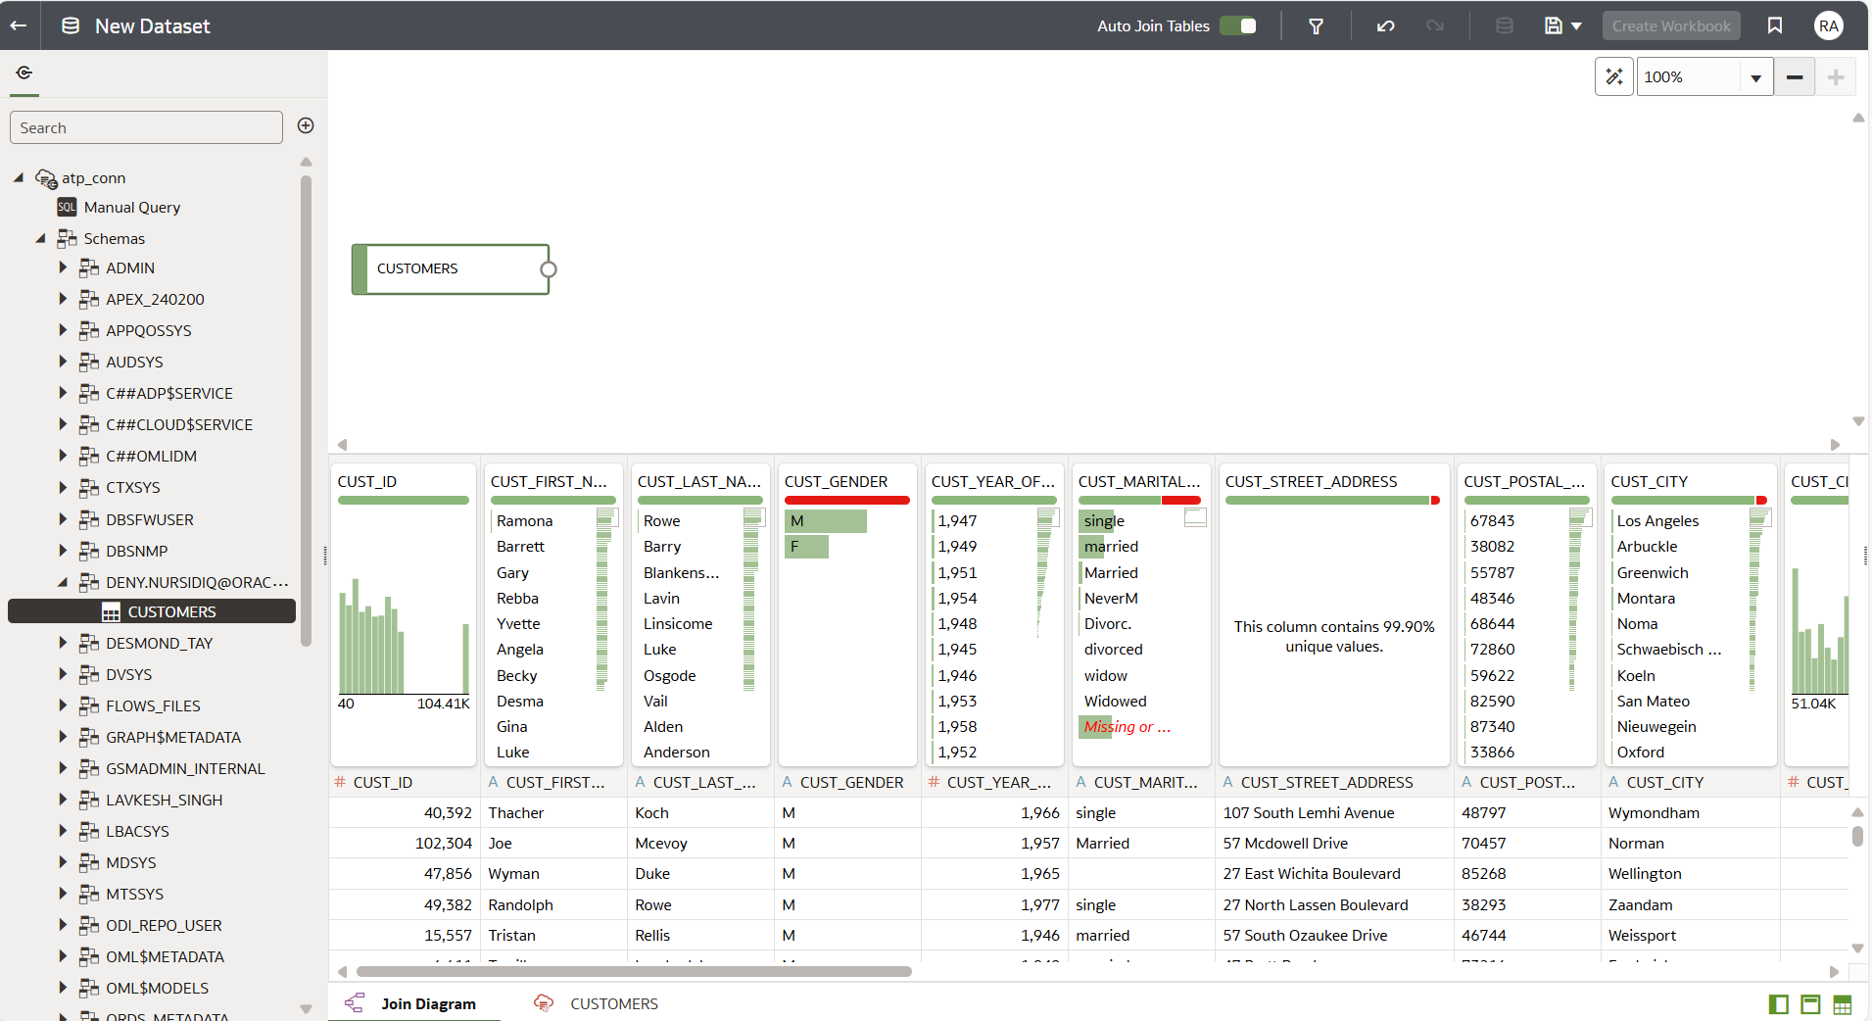

Koneksi dari compartement yang berbeda (ResearchPlatform to MLModels)
Create dataset
Create connection
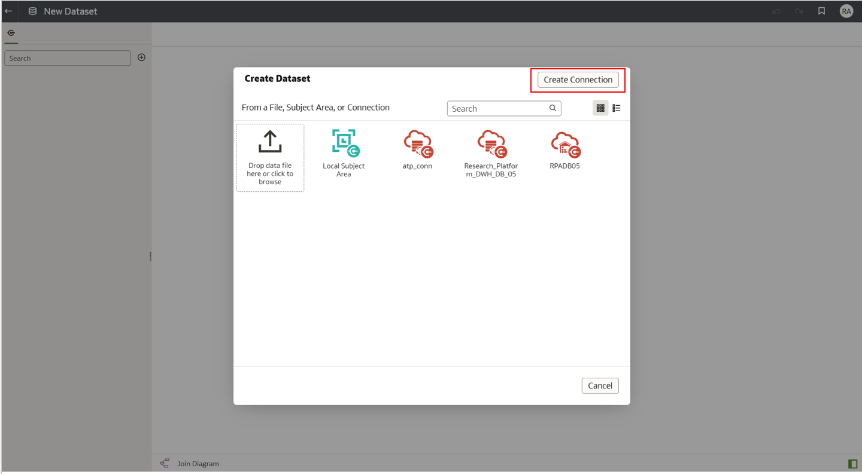
Pilih Oracle Autonomus Transcation Processing
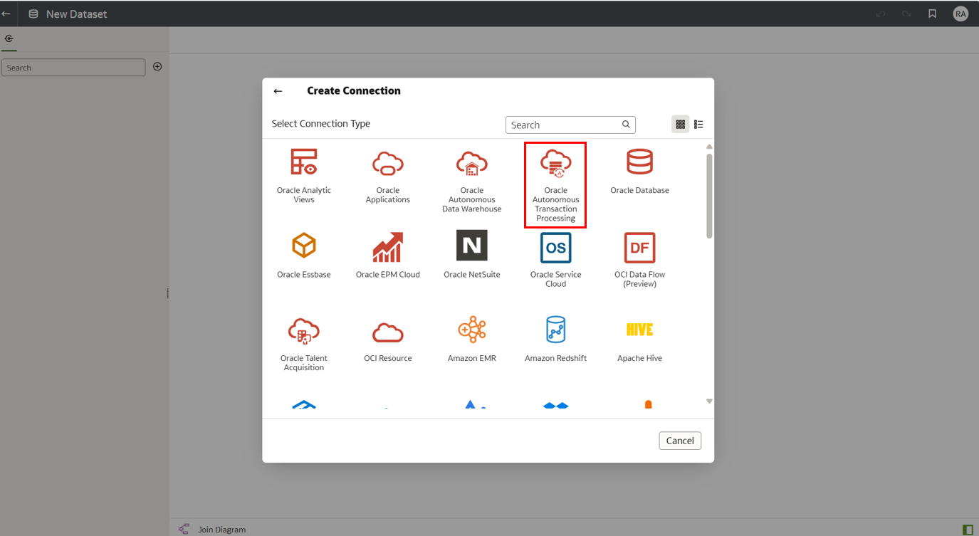
Add connection parameter
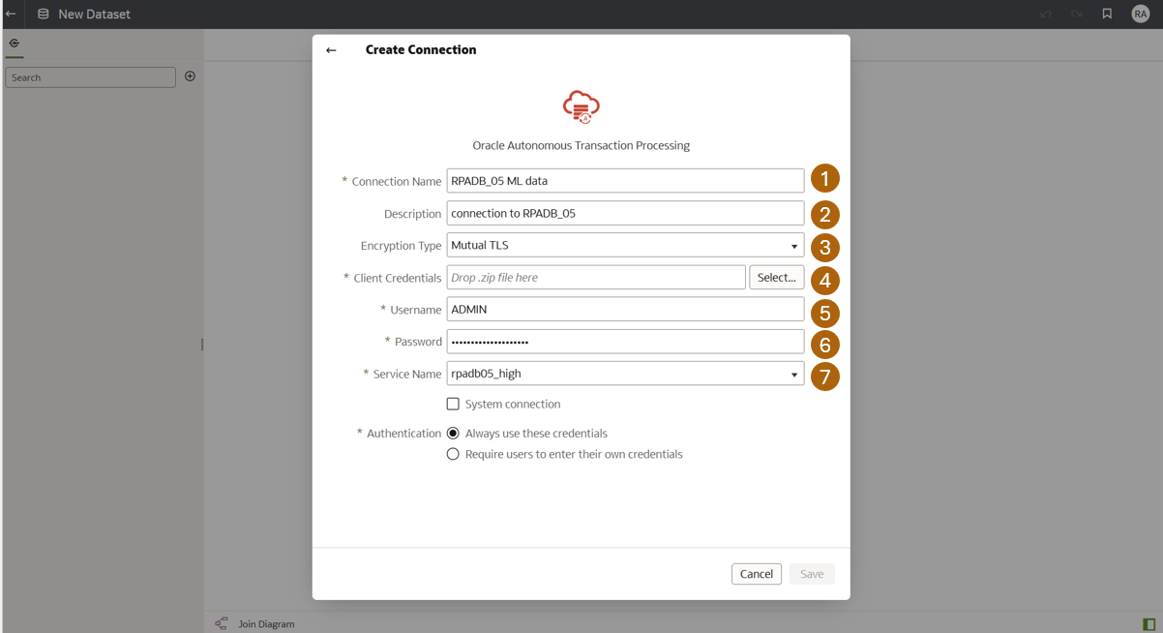
Data worfklow
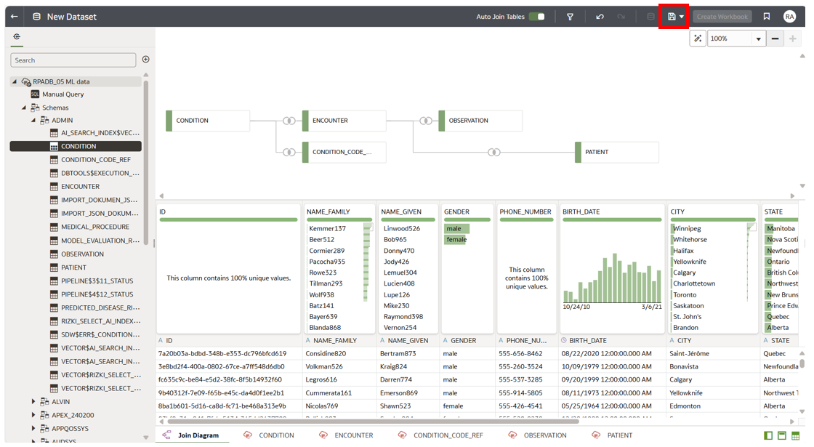
Add formula
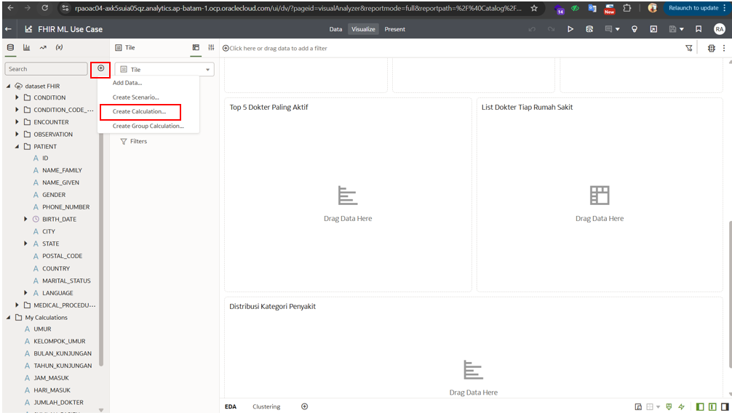
Drag kolom ke dalam formula form
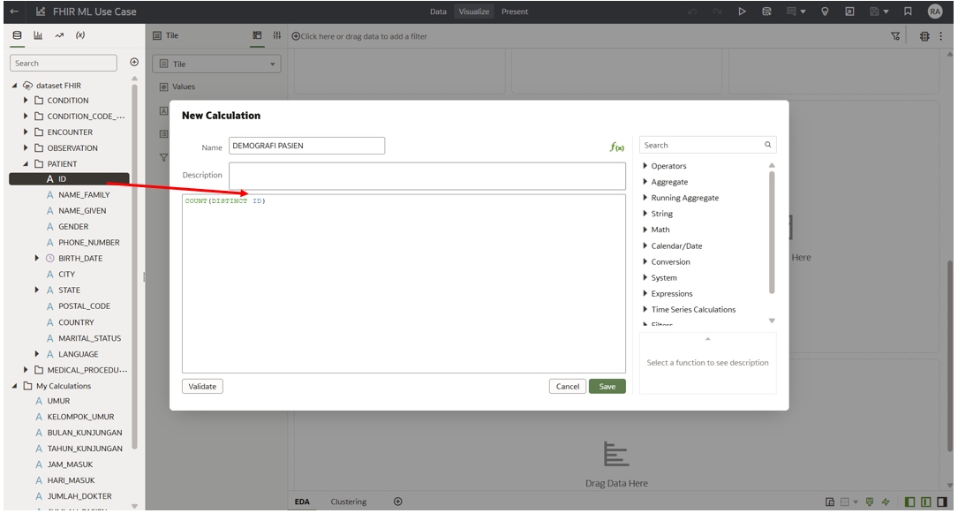

Create Model
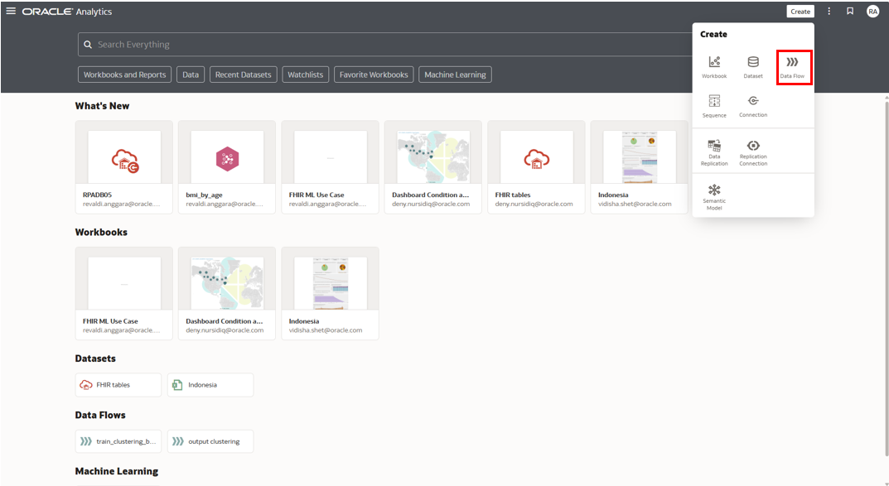
Pilih dataset, Trasnform Column, Clusterting
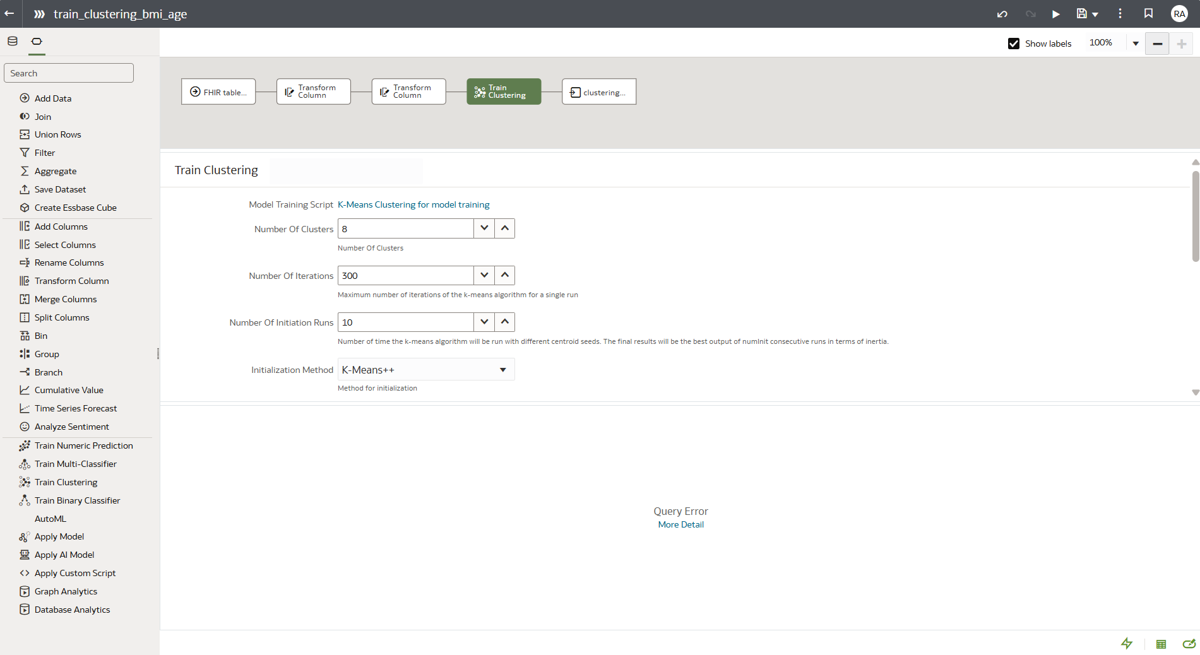
Save model
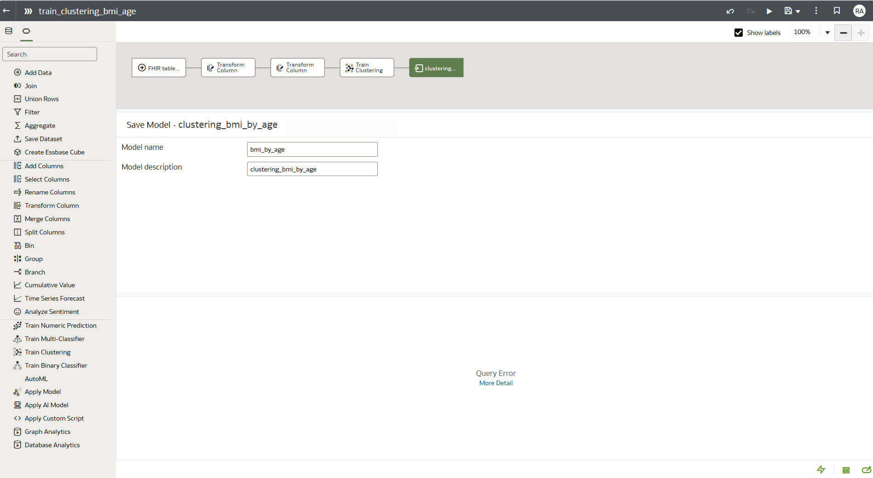

Sharing Model
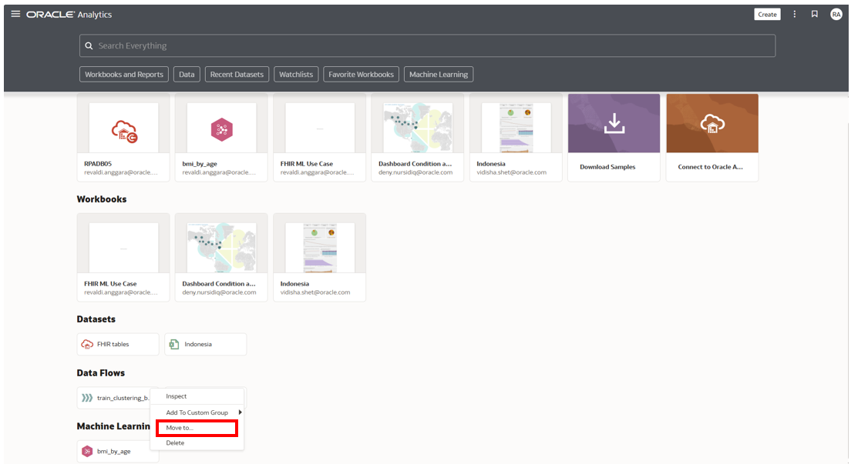
Shared Folder
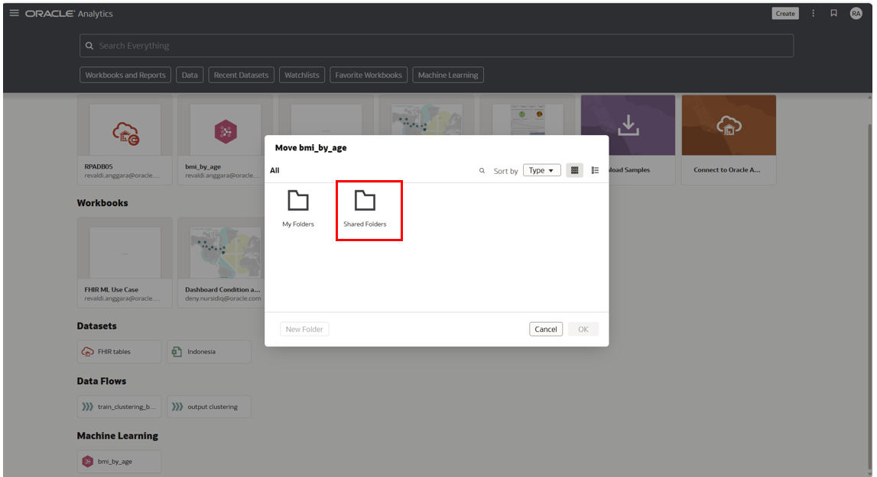

Chat with Data Visualization
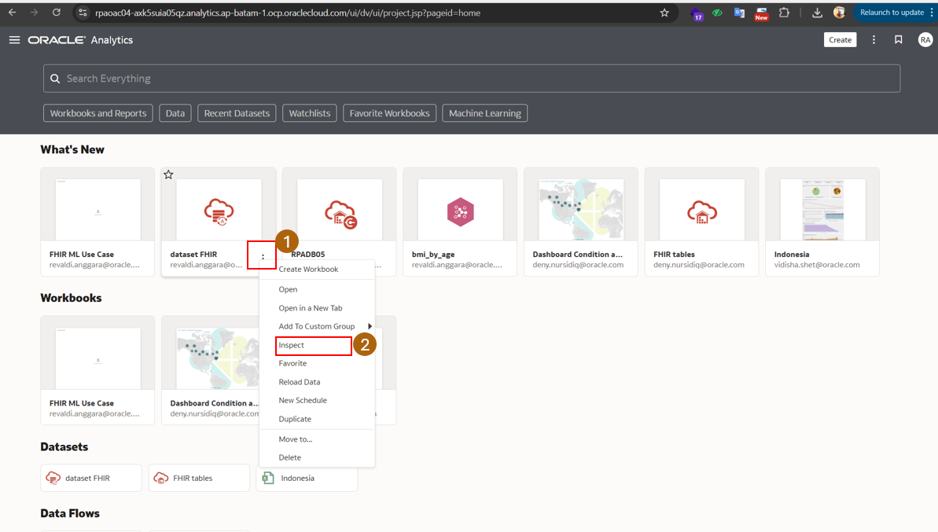
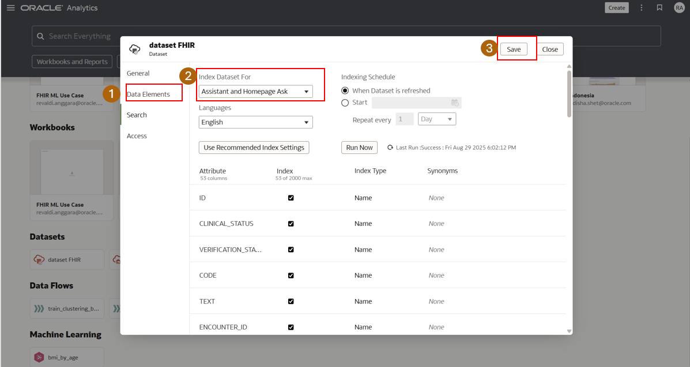
Chat with AI chatbot asistant
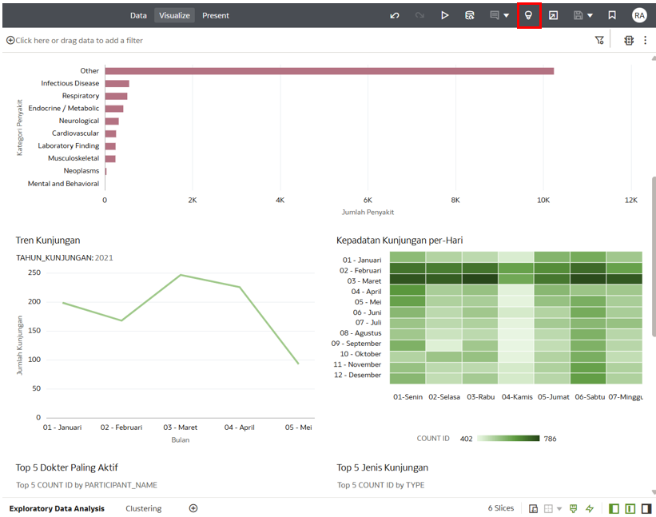
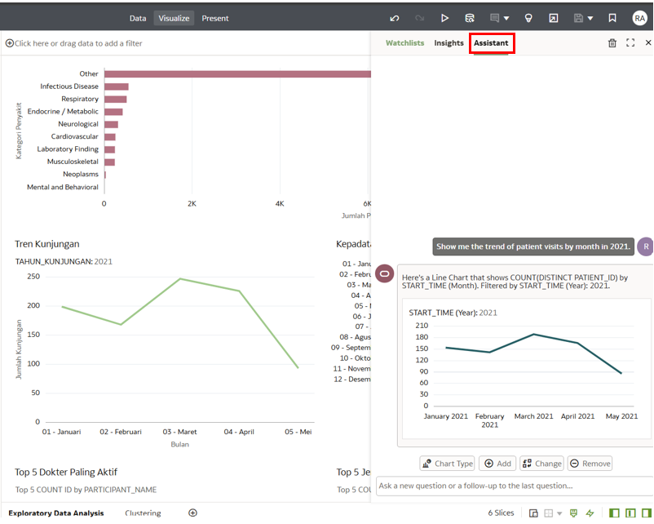
Sample pertanyaan:
- Show me the trend of patient visits by month in 2021.
- Which day of the week has the highest number of patient visits?
- List the top 5 most common visit types among patients.
- Who are the top 5 most active doctors based on encounter count?
- Show the distribution of disease categories among patients.
Summary insight
Set Preserve Grain di OAC pada data flow, pilih salah satu Table yang jadi acuan
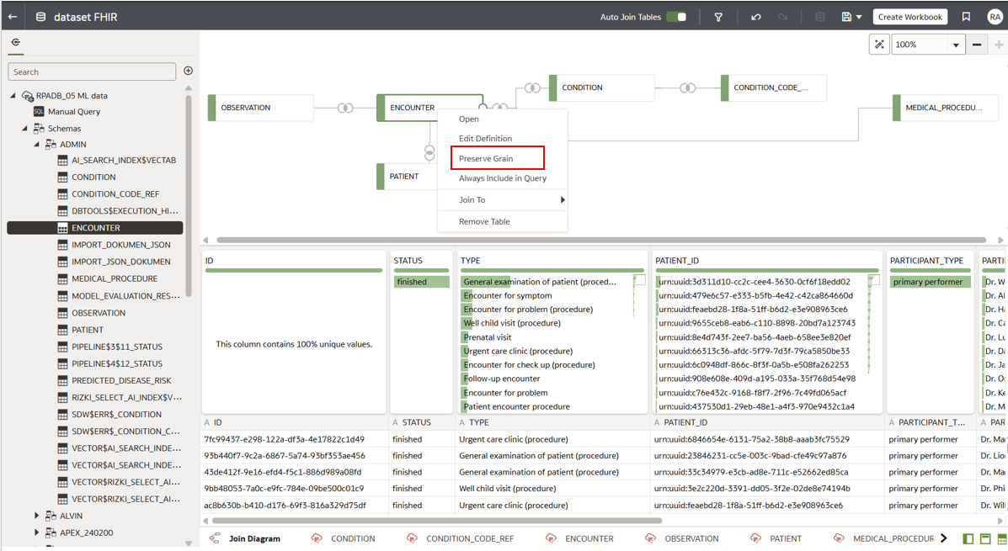

Atau klik kanan pada spesifik kolom, Explain.
